Tri-State Ability Art Show
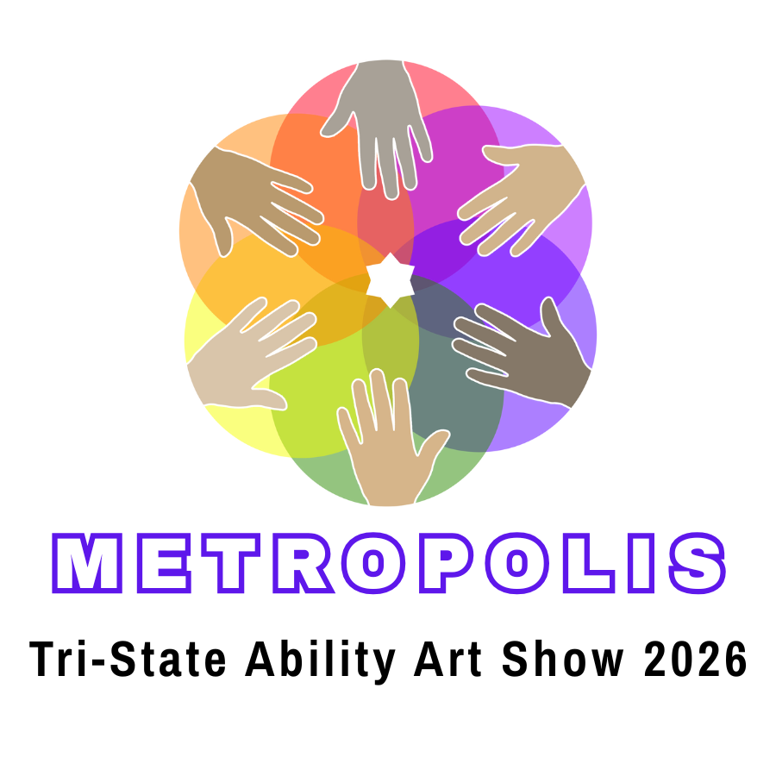
Frequently Asked Questions

What is the deadline for submitting artwork?
All artwork must be received or placed in one of the Community Drop-off locations found in the Submission Packet by Thursday, March 26, 2026.

Who decides what artwork is judged and what artwork is not?

It’s the artist’s choice. But in order to participate in jurying, the guardian or teacher MUST complete both the Juried Artwork Entry Form found on page 8 of the Submission Packet AND the Submission Form on page 7. Only one entry can be submitted to a juried category. If a student is submitting two art entries, only one may be judged and requires the Juried Artwork Entry Form for the artwork to be judged. Again, participating in jurying is completely OPTIONAL.

The jury consists of members of the listed partnering organizations for each of the juried categories; this includes executive directors, advisory board members, curators, and art educators depending on the organization and who the organization selects to jury within their organization. Y.A.L.E. School does not jury but organizes the jurying process and award distribution.

How do I submit artwork for my student or child?
You may choose one of the following methods to submit artwork:
By appointment, two- and three-dimensional artwork can be dropped off at Y.A.L.E. School, Ellisburg Campus (address below). To schedule drop-off time, please contact Karen Donnelly, kdonnelly@yaleschoolnj.com.
1

Entries can also be mailed to:
2
Y.A.L.E. School Ellisburg Campus
11 Connecticut Avenue
Cherry Hill, NJ 08002
Attn: Art Show
3
Use a Community Drop-off Box during regular library hours at one of the following locations between the dates of March 13 – March 26:

Lillian Marrero Library William G. Rohrer Memorial Library
601 West Lehigh Avenue 15 MacArthur Blvd
Philadelphia, PA 19133-2228 Haddon Township, NJ 08108

How will artwork be returned?
Picking up artwork:
If you wish to arrange to pick-up your artwork after the event, please contact Karen Donnelly (kdonnelly@yaleschoolnj.com) and you will receive a reply with pick-up times. Artwork can be picked up at the Y.A.L.E. School Ellisburg Campus, 11 Connecticut Ave, Cherry Hill, NJ 08002.

Return shipment:
If you wish to have your artwork shipped back to you, please be sure to include return shipping postage with the artwork when it is delivered to our school. Artwork will be shipped back to you within two weeks after the event. For cost-efficient shipping, consider purchasing a pre-paid shipping label online through the USPS for one of their Flat Rate boxes. These pre-paid shipping labels can only be bought online, and not at the USPS customer service counter. USPS Flat Rate cardboard boxes come in multiple sizes and can be acquired for free at the post office. Please note that USPS will honor Flat Rate shipments shipped after the 3-day shipping window that is denoted on their website at the time of label purchase.

Can I pick-up the artwork at the Tri-State Ability Art Show while the event is ongoing?
No, but you are able to collect artwork between 3pm-4pm on Saturday April 25th directly after the event has ended if you so wish. Please see the other artwork return options mentioned in the Submission Packet for more information regarding an artwork return shipment or arranging a pick-up appointment. Art teachers and guardians will be directly contacted with further details after their artwork is initially received by the Y.A.L.E. School.

Where is the Tri-State Ability Art Show held?
The event is hosted at the Y.A.L.E. School Performing Arts Center located at 750 W. Marlton Pike, Cherry Hill, NJ 08002. The building is located at the corner of W. Rt.70 and Connecticut Ave.

When is the Tri-State Ability Art Show 2026 being held?
The Tri-State Ability Art Show 2026 is open for two days:
Opening Reception & Awards Ceremony: Friday, April 24 from 6 p.m. to 9 p.m. – Tour the gallery and attend a short awards presentation with ASL interpreters present; children of all ages will also enjoy craft table activities while listening to music from young musicians.
Art Show Gallery Hours: Saturday, April 25 from 10 a.m. to 3 p.m. – Enjoy the gallery displays and attend our second annual Craft Fair on premises tabled by young artists and local community artists. Free art making workshop, activities for kids, and a food truck will also be available.
Who can attend the Art Show and Craft Fair?
Anyone! This is a free public event.
Who can submit artwork to the Tri-State Ability Art Show?
Students ages 5-21 who have either an IEP or 504 plan and who are currently enrolled in school or a Standard 9 transitional life skills program.
How many artworks can I submit to the Art Show?
Each young artist can submit up to 2 artworks to be displayed. However, if the student would like their artwork to be submitted to one of our juried categories to receive an award, only 1 of their artworks will be juried.
Collaborative artworks completed by 2 or more students do not count towards the 2-artwork count, but a collaborative artwork juried submission will grant each of the collaborating young artists with the same award title, but with separate award ribbons and certificates to keep. Collaborative artworks still abide by the 1 juried entry rule.
Do all students who submit to have their artwork juried get awards?
Yes! ALL students who fill out the Juried Artwork Entry Form to have their artwork juried will receive an award. The Awards Ceremony will be held on April 24th at 7pm in our Performing Arts Center. Students who had their artwork juried will be given their awards certificate. When their artwork is returned to them after the conclusion of the event, their awards ribbons will be returned along with the artwork.
Important Note: If your young artist/s want their artwork to be juried, you MUST fill out the Juried Artwork Entry Form which is included in the Submission Packet. You must have that form, along with the Artwork Submission form dropped off with the artwork/s.
Do young artists have to attend the Awards Ceremony in order to get their awards?
No, young artists who are not able to attend the Awards Ceremony at 7pm on Friday, April 24th will have their awards certificates, juried commentary paper, and awards ribbon returned to them with their artwork after the event has concluded. If the young artist is able to attend the Tri-State Ability Art Show on Saturday, April 25th between 10am-3pm, they will be able to get their award certificate at the front check-in desk of the Art Show.
Will American Sign Language translators be present during the Tri-State Ability Art Show?
Yes, ASL translators will be present during the Awards Ceremony held at 7pm on April 24th in our Performing Arts Center.

Is the event wheelchair and mobile accessible?
Yes, there is an elevator located on the right side of the Performing Arts Center; the elevator is accessible from the parking lot and the Art Show is held on the second floor of the building. Handicap and van-accessible parking spots are available. Parking spots are first-come-first-serve but if you would like to reserve a handicap parking space to guarantee van accessibility, please contact Karen Donnelly at kdonnelly@yaleschoolnj.com. Wheelchair seating for the Awards Ceremony is also available; reserved seating can be arranged upon request as well.
Spacious handicapped bathrooms are also available on both the first and second floors of the Performing Arts Center.
What if my young artist has a visual impairment?
Please contact Karen Donnelly at kdonnelly@yaleschoolnj.com if you would like us to provide vision accommodations. We are able to translate awards certificates in Braille upon request and may be able to provide other tactile accommodations as well.
If my young artist or a family member needs additional accommodations at the Art Show or Craft Fair, who can I contact?
Please contact Karen Donnelly at kdonnelly@yaleschoolnj.com if you would like to inquire about additional accommodations that we may be able to provide to young artists and their families.

IMPORTANT:
Be sure to refer to the Submission Packet (yaleschoolnj.com/artshow) for complete details, instructions, and guidelines.

