Application for Novo Nordisk Project SEARCH
2024-2025 Program Year

Name: _________________________________________________

Date Submitted: ___________

https://yaleschoolnj.com/novo-nordisk-project-search/

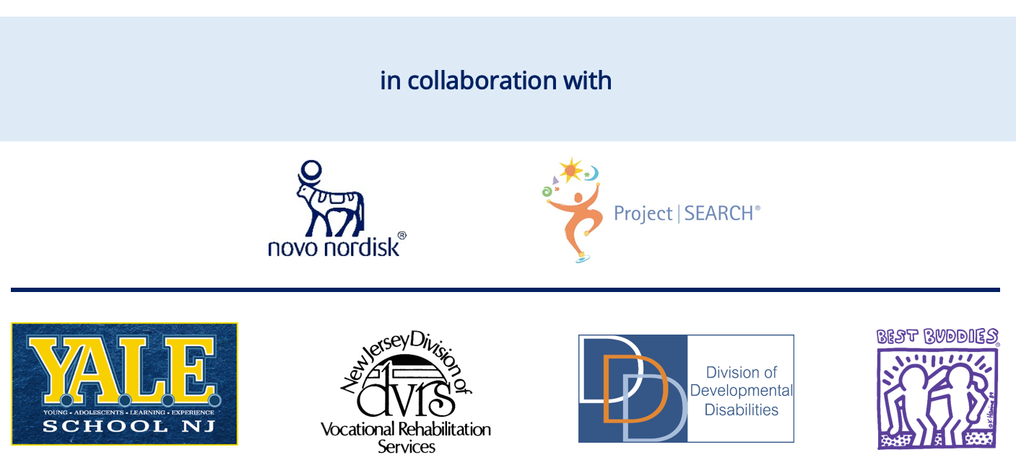

APPLICATION FOR NOVO NORDISK Project SEARCH ADMISSION
- APPLICANT PERSONAL INFORMATION:

Name: ________________________________________________________________________ Last First Middle

Address: ________________________________________________________________________ b Street City Zip Code

Applicant E-mail: __________________________________________________________ ______________ (Please create a professional G-mail account)
Applicant Home Phone: _____________________________________________________

Applicant Cell Phone: _______________________________________________________

Date of Birth: ___________________________________ Male Female Non-Binary

Social Security Number (last 4 digits):__________________________________________

Educational Classification: ____________________________________________________________

Applicant lives with _________________________________Relationship _____________

School District of Residence: ________________________________________________

District Case Manager: _____________________ Email:___________________________

Phone: __________________________________________________________________

B. __________________________ WORK HISTORY
Student Name:

List jobs you do or have done in school or in the community. List most recent first:
Employer: | Job Duties | Job Coach on Site | Paid | Unpaid
Start Date: | 1. |  □ | □ | □
End Date: | 2. |  □ | □ | □
Title: | 3. |  □ | □ | □
Supervisor Name/Contact: |  |  □ | □ | □

Employer: | Job Duties | Job Coach on Site | Paid | Unpaid
Start Date: | 1. |  □ | □ | □
End Date: | 2. |  □ | □ | □
Title: | 3. |  □ | □ | □
Supervisor Name/Contact: |  |  □ | □ | □

Employer: | Job Duties | Job Coach on Site | Paid | Unpaid
Start Date: | 1. |  □ | □ | □
End Date: | 2. |  □ | □ | □
Title: | 3. |  □ | □ | □
Supervisor Name/Contact: |  |  □ | □ | □

Have you ever been fired, or asked to resign from a job?
Yes | □ | No | □

If yes, please explain:
____________________________________________________________
Have you ever quit a job?
Yes | □ | No | □
If yes, please explain:

- ________________________________ REFERENCES:
Student Name

List Three Non-Family References (People who have first-hand knowledge of your work performance):

 | Name | Title | Phone Number | Email Address
1.
2.
3.

PLEASE ATTACH YOUR RESUME.

- PARENT/GUARDIAN* PERSONAL INFORMATION (To be filled out by parent/guardian)
Parent/Guardian #1: _________________________________________________________________________
Address: _________________________________________________________________________ b Street City Zip Code
E-mail: ___________________________________________________________________
Home Phone: ______________________________________________________________
Cell Phone: _______________________________________________________________
Name and address of employment: _________________________________________________________________________
Parent/Guardian #2: _________________________________________________________________________
Address: _________________________________________________________________________ b Street City Zip Code
E-mail: ___________________________________________________________________
Home Phone: ______________________________________________________________
Cell Phone: _______________________________________________________________
Name and address of employment: __________________________________________________________________________
*Have you been granted court-approved legal guardianship by your county's surrogate court?*

Yes No

Scope of Guardianship:

General Limited Not sure

If limited, please indicate the areas of guardianship established by the court below (i.e. medical, financial, legal, vocational, etc.)
__________________________________________________________________________________

*IMPORTANT: Attach a Copy of the Official Letter from the Surrogate's Court as applicable verifying the type of guardianship in place.

- AGENCY SUPPORTS AND BENEFITS (Check all boxes that apply.)

- I have met with a representative from Division of Vocational Rehabilitation (DVR).
- I have an open case with DVR.* Name of Counselor: ________________________
Phone: ______________________________________________________
- I am eligible for DDD. Name of Support Coordinator: _________________________
Phone: ______________________________________________________
- I have Medicaid.
- I am eligible for SSI or SSDI Benefits.

*IMPORTANT: Be sure to Complete DVR Referral Form and Include with Application.

CONFIDENTIAL REFERRAL FORM

Vocational Rehabilitation Agencies assist individuals with disabilities to prepare for, obtain and/or keep suitable jobs. The rehabilitation services the agency can provide depend on the availability of State and Federal funds and on the availability of other programs and services. All individuals have the responsibility to: participate financially in their plan to the best of their ability; obtain services only with prior written approval; cooperate by using community services when they can be of help in the rehabilitation program; maintain regular contact with the VR agency counselor; and go to work when the VR program is completed.
Name: Date:
Previous Name (if any):
Address:
City: NJ Zip Code: County:
Social Security #: DOB: Gender:
Primary Phone #: Secondary Phone #:
E-mail Address:
Have you ever applied to DVRS before? Yes No If Yes, When? :
Referral Source Name/Organization: Y.A.L.E. School Project SEARCH at Novo Nordisk
Disability:
Do you receive Social Security Benefits? SSI: Yes No SSDI: Yes No
Do you receive Welfare Benefits? GA: Yes No TANF: Yes No FS: Yes No
Primary Language:

If records documenting disability are available, please include with referral to expedite eligibility process.
To Be Completed by DVRS Staff:
Comments:
Intake Appointment:
Counselor #: Application “00”

- SCHOOL STATUS
Check all boxes that apply.
- I have all my credits for graduation.
- I still need the following classes to graduate. (Please list the classes still needed for graduation)
  - _______________________________
  - _______________________________
  - _______________________________
- I still have one or more years of school eligibility. (See Guidelines for more information about eligibility for students 18-21).

I will turn age 21 on: _________________
(Date)

- ATTENDANCE
Check the box that applies.
- I have had no absences or lateness within the past school year.
- I have had 1 – 5 absences or lateness within the past school year.
- I have had 5 – 10 absences or lateness within the past school year.
- I have had 10 or more absences or lateness within the past school year.
- I have a medical condition that requires frequent hospital stays/excessive doctor/clinic visits. (more than 20 days)
- If yes to 10 or more days:

Reasons why I have missed so much school: ___________________________________________________________________
____________________________________________________________________

- STUDENT WORK INTEREST

The goal of Project SEARCH is for you to get a job where you:
- Work in an integrated setting. This means you work with people with and without disabilities.
- Are paid the typical wage for the job.
- Work at least 16 hours each week
Are you willing to work 16 or more hours a week in an integrated setting after you finish Project SEARCH?
Yes |  | No

Where would you like to work after you finish Project SEARCH?
____________________________________________________________________________

Does your family support your work goals?
Yes |  | No

I. HEALTH INFORMATION

Medications prescribed for student:

Medication | Dosage | Time of day

List any health or medical issues that may impact a successful job placement:

_______________________________________________________________________________________________________________________________________________________________________________________________________________________________________________________________

- PERSONAL STATEMENT
Please answer the following question to the best of your ability. If someone else helps you, ask them to write down the answers in your own words. Use as much space as needed.

- Why do you want to be a Project SEARCH intern?

_____________________________________________________________________________________________________________________________________________________________________________________________________________________________________________________________________________________________________________________________________________________________________________________________________________________________________________________________________________________________________________________________________________________________________________________________________________________________________________________________________________________________________________________________________________________________________________________________

- PROJECT SEARCH INTERN AGREEMENT

Do you or your parent/guardian have any concerns with signing the below contract if you are accepted?
Yes |  | No

If yes, please explain:

I have read the below terms and conditions and agree to accept my placement in the Project SEARCH program. I understand that I may be asked to leave Project SEARCH if I fail to follow the terms and conditions.
I, ___________________________, understand that I have been accepted into the Project SEARCH program and must abide by the following terms and conditions:
- I will complete all onboarding requirements of Novo Nordisk as provided by me by the Novo Nordisk Steering Committee Representative.
- I will complete three unpaid job rotations within Novo Nordisk.
- I will attend the program every day for 6 hours per day (8:30 a. m – 2:30 p.m.), Monday through Friday.
- I understand that the Project SEARCH program follows the Y.A.L.E. School Project SEARCH school year calendar.
- I will contact my instructor and departmental supervisors when I am absent or tardy.
- I will adhere to the Novo Nordisk Attendance Policy and disciplinary procedures. Regular attendance is essential for success in learning the skills in each internship rotation. Interns not adhering to the attendance policy will be withdrawn from the program.
- I will provide my own transportation to Novo Nordisk.
- I will follow all the policies and procedures established by Project SEARCH and Novo Nordisk.
- I will dress according to the dress code and uniform requirements of the assigned host site and/or rotation.
- I will attend 6 Employment Planning Meetings during the program year with my PS Instructor, VR counselor, job developer, skills trainers, and family members. I will be an active participant and be forthcoming with information of my performance during each meeting.
- I understand that the desired outcome for me in Project SEARCH is full or part-time (no less than 16 hours per week) paid employment in the community.
- I will maintain scheduled meetings with the job developer or skills trainers from Best Buddies, be an active participant in pursuing employment, and utilize my family supports and community connections to obtain meaningful employment of 16 hours or more.
- Parent, caregiver, or support person agrees to attend 6 Employment Planning Meetings held during the 2024-2025 school year and to support the policies of the Project SEARCH at Novo Nordisk program including but not limited to policies regarding transportation, attendance, and good hygiene and to support the intern’s goal of employment in the community at the end of the program
- I understand that Incorrect or incomplete information provided on this application could impact the student’s ability to enter or complete Novo Nordisk Project SEARCH.
- Release of Information: The student records concerning my son/daughter may be transferred to Y.A.L.E. School for review by the Y.A.L.E. School Admissions Coordinator and by the Project SEARCH program staff and Selection Committee Team Members.
- Equal Opportunity: Career placement will be made without regard to race, color, national origin, sex, age, religion or presence of a disability.

Student Signature: _________________________________ Date: ___________________

Parent/Guardian Signature:___________________________ Date: ___________________

We have received approval to apply for admission to Novo Nordisk Project SEARCH from the school district case manager. We also understand that Novo Nordisk Project SEARCH involves a dual application and admissions process with Y.A.L.E. School as the special education partner of Novo Nordisk Project SEARCH. By submitting this application, I understand that the candidate must be accepted as a Y.A.L.E. School student to participate, as well as by the Novo Nordisk Project SEARCH Selection Committee.

Parent/Guardian Signature: ________________________ Date: _________________

- PREPARER:

Student Signature

If this application has been completed by someone other than the student, please provide the following information and sign:

Name Title Phone Number Date

Signature
Project SEARCH Admissions and Onboarding
CONSENT FOR RELEASE OF INFORMATION
February 2024 – August 2025

As the parent/guardian of , I give my permission for the Project SEARCH at Novo Nordisk Steering Committee members listed below to release, obtain and/or discuss information within the committee for the purpose of best meeting the educational, transitional, and employment needs of my son/daughter.

I understand that this information will remain strictly confidential among Steering Committee members, who may review and share the information to guide planning, develop strategies and identify resources. Information may include but is not limited to: a) assessment results in the student’s educational file, such as learning evaluations, vocational evaluations, other work-related assessments or interest inventories previously completed by the intern b) interview and intake information and results c) job performance information d) ) medical concerns that may impact attendance or safety e) circumstances that may affect emotional wellness or stability and require supports.

This consent will remain in effect for 18 months, which includes but is not limited to the interview and admissions period, the onboarding process and the program year. I understand that I may revoke this consent at any time by providing written notice to the Y.A.L.E. School at 2127 Church Road, Cherry Hill, New Jersey 08002.
Att: Karen Huber, Clinical and Admissions Coordinator.
.
SIGNATURE REQUIRED
____________________________________________

Parent/Guardian Signature

____________________________________________

Student Signature

___________________________________________

Date _________

Members: Division of Vocational Rehabilitation (DVR) Division of Developmental Disabilities (DDD)
Best Buddies, International
Novo Nordisk Staff Members
Y.A.L.E. Staff Members or Representatives
School District Staff Member or Representatives

c: Student File

PHOTO RELEASE
Y.A.L.E. School
Project SEARCH at Novo Nordisk

I hereby consent to the use of _______________________’s name, image, photograph, or likeness by Y.A.L.E. School, Project SEARCH at Novo Nordisk or their assignees or licensees, for the purpose of illustration, advertising, trade or publication, including, but not limited to school/business newsletter, slide presentations, video tapes and their use as outlined in the Student Parent Handbook, pamphlets/brochures, websites, or any other Y.A.L.E. School Project SEARCH at Novo Nordisk related materials.

SIGNATURE REQUIRED

___________________________
Signature of Parent/Guardian Date
___________________________
Signature of Student Date

