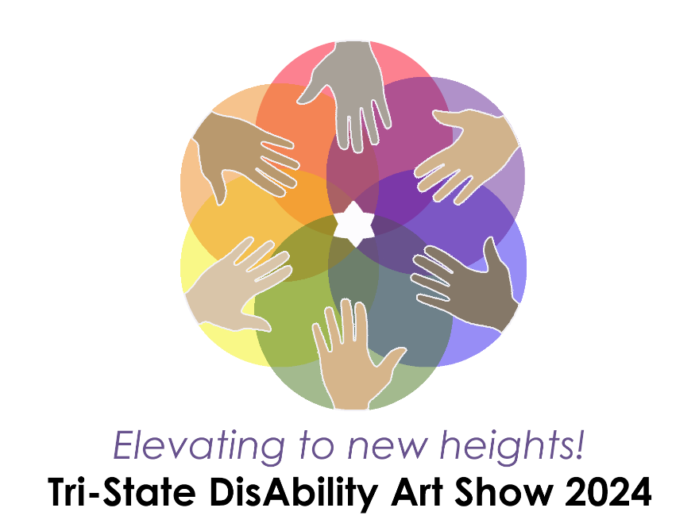
Opening Reception & Awards Ceremony - Friday, April 26th from 6pm-9pm
Gallery Hours – Saturday, April 27th from 10am-3pm

Special thanks to the community partners supporting the Tri-State DisAbility Art Show:
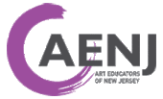

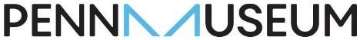

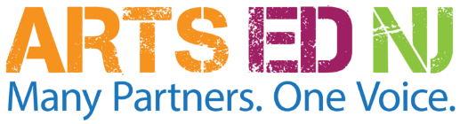
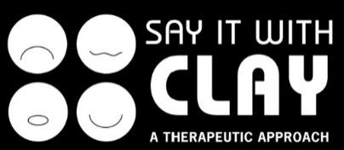

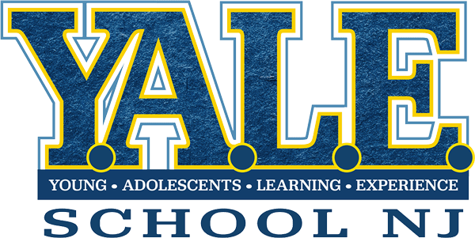
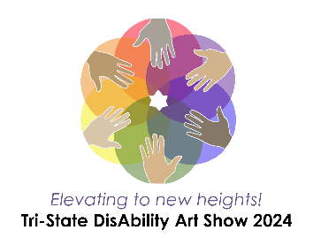
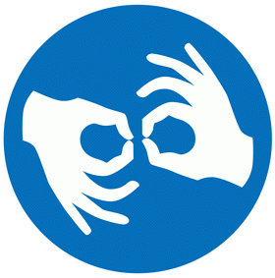

Opening Reception: Friday, April 26 from 6 p.m. to 9 p.m. – Tour the gallery and attend a short awards presentation; children of all ages will also enjoy craft table activities while listening to music from young musicians.
Art Show Gallery Hours: Saturday, April 27 from 10 a.m. to 3 p.m. – Enjoy the gallery displays and craft table activities for kids.

Artwork Submission Guidelines
Y.A.L.E. School of New Jersey is pleased to present this exciting community event for its fourth year! Submitting artwork to the Tri-State DisAbility Art Show is entirely free. While the Art Show is open to the public, young artists that participate must be in grades K-12 or enrolled in a Standard 9 program and have either an IEP or 504 plan. All should reside or attend school in either New Jersey, Pennsylvania, or Delaware. Artwork must be submitted by either a teacher or family member who is 18 years of age or older.

Participants will not be excluded on the basis of disability, ethnicity, orientation, gender, national origin, or background. The Tri-State Disability Art Show is a fully inclusive and accessible event and requires all involved to act with mutual respect and acceptance.

Section 1 – General Entry Information

Limit of 2 entries per young artist. All entries are guaranteed to be displayed. Artists may also choose to submit their artwork for judging. This is optional and not required in order for artwork to be displayed. Information about submitting art for judging in one of the juried categories is found in Section 5.

To be displayed, artwork must be school-appropriate in nature and should not include direct nudity, obscene or lewd content, violence, or weapons. Y.A.L.E. School of New Jersey reserves the right to exclude artwork that is deemed inappropriate, inflammatory, or upsetting to a school-age population based on social emotional considerations.

In this packet, please find an Artwork Label sheet with instructions. All entries must be labeled accordingly. In addition, teachers and guardians must complete one Submission Form for the students participating from their schools. That form is also included.

Section 2 – Drop-Off and Shipment Options

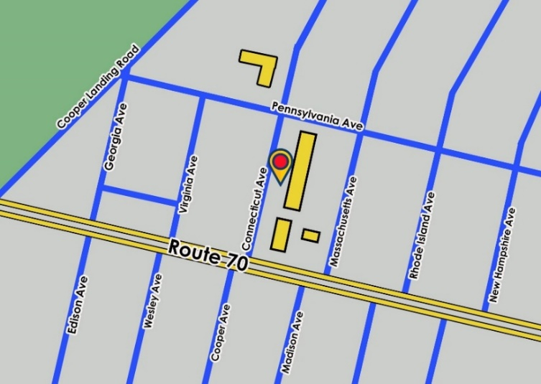
Two- and three-dimensional artwork can be dropped off at Y.A.L.E. School of NJ, Ellisburg Campus by appointment. Please contact Karen Donnelly (kdonnelly@yaleschoolnj.com) to schedule a drop-off time.
Entries can also be mailed to the address below with ‘Attn: Art Show’ on the envelope or package. All artwork must be received or dropped off by Friday, April 12.
Please include a return shipping label with any mailed entries; please note that the USPS will honor shipment of packages past the denoted 3-day return shipment date. Return shipping labels can be purchased online at USPS.com for a flat rate.

Y.A.L.E. School of NJ, Ellisburg Campus
11 Connecticut Ave
Cherry Hill, NJ 08002

Community Drop-off Boxes
The following library partners have generously allowed us to place artwork drop-off boxes at their locations. Please attach your completed submission form and optional juried entry form to all entries prior to drop- off. Labels indicating student names, school, and grade should also be affixed to the front of each artwork prior to drop-off. Note that the locations are unable to accept three-dimensional artworks (ceramics, sculptures, etc.) or artwork exceeding 23” x 13” in size as that is the interior dimensions of the drop-off bin. The lid to drop-off bins must be closed.
The final day for drop-off boxes is April 12.
Eastwick Library  2851 Island Ave  Philadelphia, PA 19153  Library Hours:  Sunday: Closed  Monday: 12 p.m. - 8 p.m.  Tuesday: 10 a.m. - 6 p.m.  Wednesday: 12 p.m. - 8 p.m.  Thursday: 10 a.m. - 6 p.m.  Friday: 10 a.m. - 5 p.m.  Saturday: Closed  Parking is available on the street and in the adjoining parking lot.  The drop-off box is located in the Children’s Literature section of the library. | Moorestown Library  111 W 2nd St Moorestown, NJ 08057  Library Hours:  Sunday: Closed  Monday: 9:30 a.m. - 9 p.m.  Tuesday: 9:30 a.m. - 9 pm.  Wednesday: 9:30 a.m. - 9 p.m.  Thursday: 9:30 a.m. - 9 p.m.  Friday: 9:30 a.m. - 5 p.m.  Saturday: 9:30 a.m. - 5 p.m.  Parking is available in the adjoining parking lot.  The drop-off box is located in the main lobby of the library.

Section 3 – Types of Submissions and Criteria by Category

Three-Dimensional Media Artworks
Types Accepted: | Criteria:
- Ceramics  - Cardboard or Paper Sculptures  - Textile Artworks  - Mixed Media  - Wood Sculptures  - Metal/Wire Sculptures  - Mosaics | - Dimensions should not exceed 3’ x 4’ in square footage.  - Artworks should not have any sharp or unsafe components or textures that are visible.  - Artworks should not require any type of wall mounting.  Note: Three-dimensional artworks cannot be dropped off at library drop- off boxes due to space and artwork security.
Two-Dimensional Media Artworks
Types Accepted: | Criteria:
- Drawings  - Paintings  - Collages  - Digital Prints  - Photography  - Mixed Media  - Printmaking  - Textiles | - Dimensions should not exceed 18” x 24”.  - Artwork should not be framed unless a tripod stand is provided when the artwork is dropped off. Library drop-off boxes will not accept any props.  - Matted artworks will be accepted.

Digital Artworks
Types Accepted: | Criteria:
- Videos or Animations  - Photographs  - Graphic Designs | - File must be emailed to kdonnelly@yaleschoolnj.com.  - Video file formats must be submitted as .AVI, .MOV, .MP4, or .GIF  - Image file formats must be submitted as .PNG, .JPG, or .JPEG  - If the file is large, it is recommended that you upload the file on Google Drive or Dropbox and send the file link to the email address above.  Note: All digital entries will be displayed on trolly flat screen TVs that will run on a loop rotation. All submitted digital artworks must not be plagiarized from another source.
Collaborative Artworks
Types Accepted: | Criteria:
- All media listed above | - Dimensions should not exceed 5’ x 6’ in square footage.  - Artworks should not have any sharp or unsafe components or textures that are visible.  - Artworks should not require any type of wall mounting without first contacting Karen Donnelly (kdonnelly@yaleschoolnj.com) to make sure that the artwork can be accommodated.  Note: Three-dimensional artworks cannot be dropped off at library drop-off boxes.

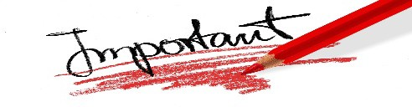
Section 4 – Display Recommendations

If the artwork requires a table display stand such as a plate display stand or tripod, it is recommended that you provide those items when you drop off the artwork. The prop can be attached to the artwork with string or tape, or packaged inside of a labeled box. Y.A.L.E. School of NJ will make every effort to provide display props, but these types of display props may be limited. Also, please note that props, displays, and three-dimensional artworks cannot be dropped off at library drop-off box locations.
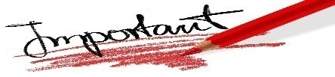
Section 5 – Juried Categories (OPTIONAL)
The Tri-State DisAbility Art Show offers juried categories for any student wishing to submit juried entries. Submitting juried entries is completely OPTIONAL. All artwork will be displayed, regardless of whether or not it is entered into a juried category.

All participants in juried categories will receive individual award recognition, an award certificate, positive juror commentary, and an award badge. No entry into a juried category will be excluded. In order to participate in jurying, the guardian or teacher MUST complete the Juried Artwork Entry Form on page 8 of this packet. Again, participating in jurying is completely OPTIONAL.

Note: If a student is submitting two art entries, only one of those artworks can be submitted to a juried category. Please indicate which of the two pieces of art is being submitted to the juried category by drawing or attaching a small star ★ on the back of the artwork so that the correct artwork can be submitted to the juried category. (See categories below on page 5).

You may enter as many students for jurying as you wish. The award ceremony will be held during the opening reception event on April 26. Award announcements will begin promptly at 7:30pm; students should arrive and sign-in at the front table by 7pm for their name to be announced. If a student is not present for the awards ceremony, their award certificate, award badge, and positive juror commentary will be returned with their artwork after the art show.
Juried Categories | Grades | Jurors
(Category 1) Penn Museum Awards – “Your Food Story” | K-12 & Standard 9 | Penn Museum - Education Program
Food remains are tiny treasure troves of data that reveal information about people’s daily lives, traditions, and culture. In Penn Museum’s Ancient Food & Flavor exhibition, learn how archaeologists study these remains to reveal untold histories and forge connections to the past. The Penn Museum encourages young artists to submit artwork to this category that celebrates the food and traditions of their family, community, and culture. All media accepted.
(Category 2) Art Educators of New Jersey – Elementary School Juried Awards Category | NJ students in grades K-5 | Art Educators of New Jersey  Advisory Council  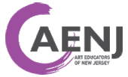
Entries in this category are from elementary students in New Jersey.
All media accepted.
(Category 3) Art Educators of New Jersey – Middle School Juried Awards Category | NJ students in grades 6-8
Entries in this category are from middle school students in New Jersey. All media accepted.

(Category 4) Art Educators of New Jersey– High School Juried Awards Category | NJ students in grades 9-12 & Standard 9
Entries from this category are from high school students in New Jersey. All media accepted.
(Category 5) Pennsylvania Art Education Association – Elementary Juried Awards Category | PA students in grades K-5 | Pennsylvania Art Education Association - Board of Directors  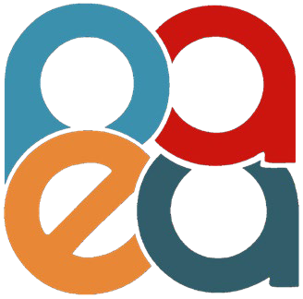
Entries from this category are from elementary students in Pennsylvania. All media accepted.
(Category 6) Pennsylvania Art Education Association – Middle School Juried Awards Category | PA students in grades 6-8
Entries in this category are from middle school students in Pennsylvania. All media accepted.
(Category 7) Pennsylvania Art Education Association – High School Juried Awards Category | PA students in grades 9-12 & Standard 9
Entries in this category are from high school students in Pennsylvania. All media accepted.
(Category 8) Perkins Center for the Arts Awards – “My Community” | K-12 & Standard 9 | Perkins Center for the Arts  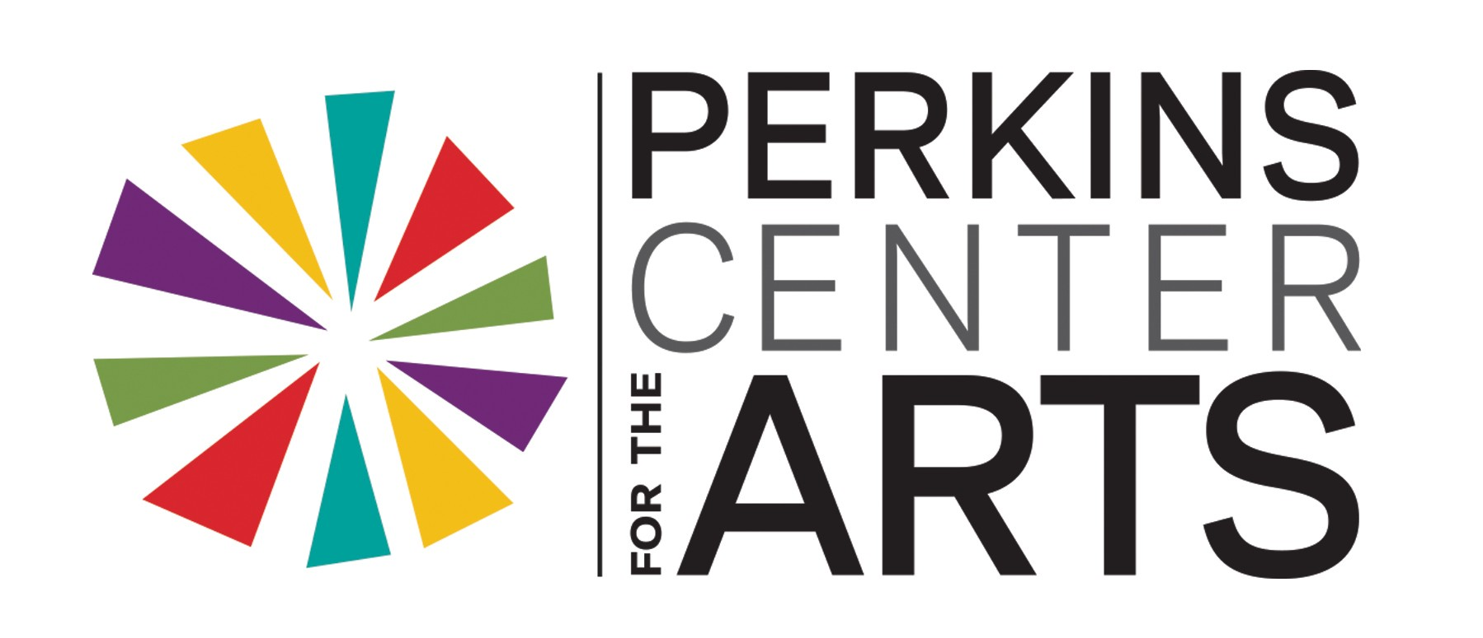
The word “community” can be interpreted by each young artist in their own way. Young artists are encouraged to think about what communities are important to them: their school community; friend community; geographic community; community of faith; activity community (sports, arts, work); or any way in which “community” resonates with them. They can use these ideas in the inspiration of their artwork. All media accepted.
(Category 9) Perkins Center for the Arts Awards- Advanced Arts Competition | 9-12 & Standard 9
Perkins Center for the Arts is pleased to jury the Advanced Arts Competition for students grades 9-12 who are considering continuing education in the arts following high school. Perkins Arts Education & Exhibition staff, and Perkins-affiliated artists will provide constructive criticism to participants that will help them improve their technical skills, support portfolio development, and encourage their further pursuit of the arts. All media accepted.
(Category 10) Say It With Clay – “Our Creatures, Our Friends” (Media specific) | K-12 & Standard 9 | Say It With Clay  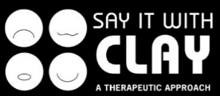
Say It With Clay is delighted to return to jury this year. Entries into this category should be ceramic/polymer artworks that represent a creature or animal through the young artist’s vision. Ceramics can either be hand-built or wheel-thrown. Media utilized may include ceramics, air dry clay, or oven-baked polymer clay.

Section 6 – Artwork Pick-Up & Return Shipment Information

Picking up artwork:
If you wish to arrange for pick-up for your artwork after the event, please contact Karen Donnelly (kdonnelly@yaleschoolnj.com) to arrange a time to pick-up your artwork. Artwork can be picked up at the Y.A.L.E. School Ellisburg Campus.

Return shipment:
If you wish to have your artwork shipped back to you, please be sure to include return shipping postage with the artwork when it is delivered to our school. Artwork will be shipped back to you within two weeks after the event. For cost-efficient shipping, consider purchasing a pre-paid shipping label online through the USPS for one of their Flat Rate boxes. These pre-paid shipping labels can only be bought online, and not at the USPS customer service counter. USPS Flat Rate cardboard boxes come in multiple sizes and can be acquired for free at the post office. Please note that USPS will honor Flat Rate shipments shipped after the 3-day shipping window that is denoted on their website at the time of label purchase.

About Y.A.L.E. School of New Jersey

Y.A.L.E. School of New Jersey is pleased to present the Tri-State DisAbility Art Show for its fourth year. Established in 1976, Y.A.L.E. School of NJ is a state-approved private school serving students in the tri-state area with campuses in New Jersey and Pennsylvania. Y.A.L.E. School of NJ provides a positive approach to students ages 3-21 with disabilities, who need a specialized setting in order to benefit from education. Y.A.L.E. School of NJ specializes in supporting students with social, emotional, learning, and behavioral disabilities. Programs are fully approved and monitored by the New Jersey Department of Education and comply with state and federal rules and regulations. Most students at Y.A.L.E. Schools of NJ are referred by their local school district; they attend at no cost to parents.

Learn more online:

www.yaleschoolnj.com

www.yaleschoolpa.com

facebook.com/yaleschoolnj
facebook.com/yaleschoolpa

@yaleschoolnj

@yaleschoolnj

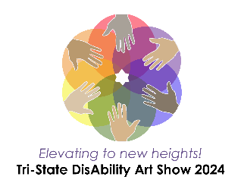
SUBMISSION FORM

Tri-State DisAbility Art Show

April 26 - 27
Y.A.L.E. School, Ellisburg Campus 11 Connecticut Ave Cherry Hill, NJ 08002
The Tri-State DisAbility Art Show is an inclusive event celebrating the talents and experiences of young artists in K-12 who are from New Jersey, Pennsylvania, or Delaware and who have either an IEP or 504 plan. Participation is entirely free and open to students in public and private schools in the tri-state area.
Opening Reception: Friday, April 26 from 6 p.m. to 9 p.m. – Tour the gallery and attend a short awards presentation; children of all ages will also enjoy craft table activities.
Gallery Hours: Saturday, April 27 from 10 a.m. to 3 p.m. – Enjoy the gallery displays and craft table activities for kids.

Limit to submitting 2 artworks per young artist. All entries are guaranteed to be displayed regardless of whether or not the artwork is submitted to a juried category. Please see the Artwork Submission Guidelines for all relevant information regarding submissions. All Artwork must be received by April 12 to be included in the art show. Please list all student names below, even the names of students who wish to have their artwork juried.

Artwork Submission Form

Full Name of Teacher or Guardian:
Teacher/Guardian Email Address:
Teacher/Guardian Phone Number:
Relationship to the Child/ren:  - Teacher  - Parent/Guardian  - Other: | Total Number of Artworks Submitted:
 | Total Number of Students Participating:
School Name: | School/Home Address:
Participating Student Names | # of Artworks | Participating Student Names | # of Artworks
*You may attach a separate sheet of paper if you have more students to list.

I, , the guardian/teacher of all participating children listed above, grant permission for the Y.A.L.E. School of New Jersey and Y.A.L.E. School of Pennsylvania Inc. to display submitted artworks for the Tri-State DisAbility Art Show 2024. I also grant permission for artworks with students’ full name and school to be used or displayed on social media, news stations and/or newspapers, or on promotional material for following art shows. I am at least 18 years of age or older and I am the legal guardian, school administrator, or teacher of the children listed above.
Signature of Guardian or Teacher: Date:

*OPTIONAL* - JURIED ARTWORK ENTRY FORM
Tri-State DisAbility Art Show 2024
April 26 – April 27
Important: Participating in juried artwork entry is entirely OPTIONAL. Before filling out this form, please refer to pages 4-5 of the submission packet for all information on jurying. This form is only required for artwork being submitted for jurying. If you have no students who would like to be juried, you do not need to fill out this form.
Please staple this form with your Submission Form. The submission form is required to be filled out. Both forms should be submitted along with the artwork no later than April 12.
Only one artwork per student is allowed to be submitted for jurying. If your student/s are submitting two artworks to the art show, please indicate which artwork you would like to be juried by drawing or attaching a small star ★ to the back of the artwork that you would like to be juried.

Full Name of Teacher or Guardian:
Teacher/Guardian Email Address:
School Name:
School Name: | Total Number of Artworks Being Submitted for Jurying:
Student Names (juried students only): | Grade: | Juried Category #  (Required)
*You may attach a separate sheet of paper if you have more students to list.
✎ Note: You may use students’ first name and last initial if you prefer. Certificate names will be printed exactly as written above. If you are a teacher, please ensure that student names are written above as the guardian would prefer.

I, , the guardian/teacher of all participating children listed above, grant permission for the Y.A.L.E. School of New Jersey and Y.A.L.E. School of Pennsylvania Inc. to submit photos of the children’s artwork to one of the external organizations, (Perkins Center for the Arts, Say It With Clay, Penn Museum, Art Educators of New Jersey, or the Pennsylvania Art Education Association), for the purpose of being viewed for jurying and given awards. I also grant permission for the above students to have their name and grade, (as written above), released to one of these organizations, as well as written on an awards certificate and in the event program brochure. I also grant permission for the listed children to have their names announced at the awards ceremony on April 26, 2024, so long as the listed children are in attendance on the night of the awards ceremony. I am at least 18 years of age or older and I am the legal guardian, school administrator, or teacher of the children listed above.
Signature of Guardian or Teacher: Date:

Artwork Labels
These artwork display labels are included for your convenience. If you choose to make your own artwork labels, please use the same format that is listed below. Adding an artwork title is optional.

Name: Grade:
School:
Name:
Grade: School:
Name: Grade:
School:
Name: Grade:
School:
Name: Grade:
School:
Name: Grade:
School:
Name: Grade:
School:
Name: Grade:
School:
Name:
Grade: School:
Name: Grade:
School:
Name: Grade:
School:
Name: Grade:
School:

