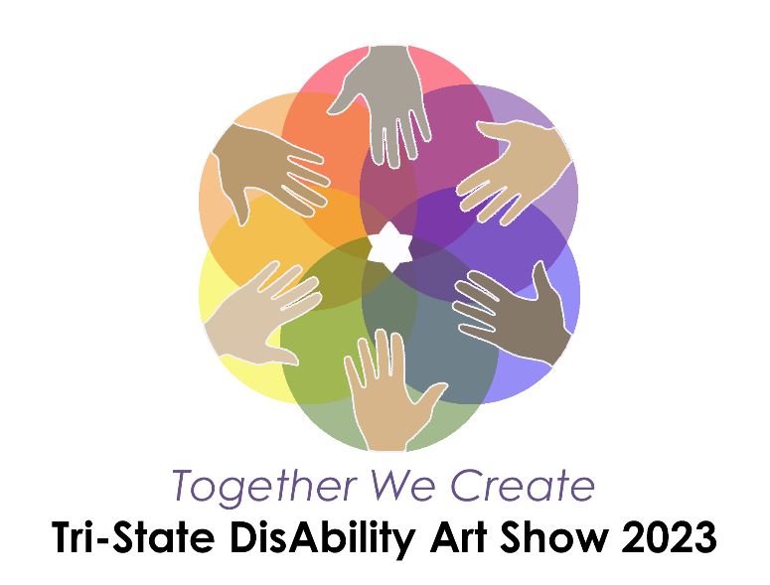
Friday, April 28 & Saturday, April 29

Special thanks to the community partners supporting the Tri-State DisAbility Art Show:
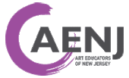

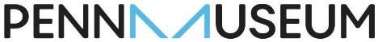

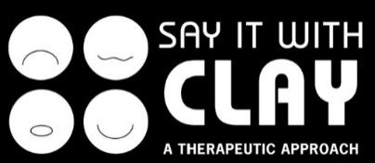

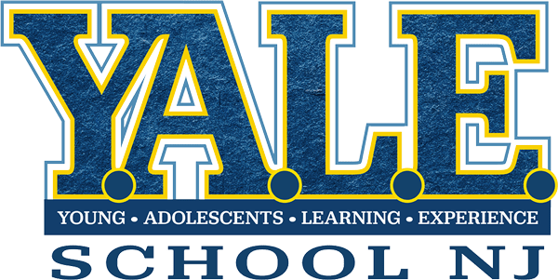
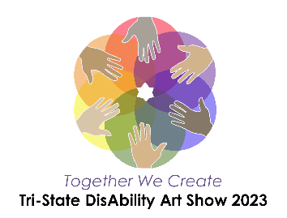
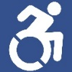
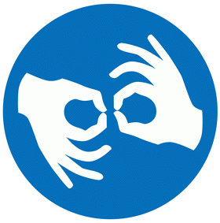

Opening Reception: Friday, April 28 from 6 p.m. to 9 p.m. – Tour the gallery and attend a short awards presentation; children of all ages will also enjoy craft table activities while listening to music from young musicians.
Art Show Gallery Hours: Saturday, April 29 from 10 a.m. to 3 p.m. – Enjoy the gallery displays and craft table activities for kids.

Artwork Submission Guidelines
Y.A.L.E. School of New Jersey is pleased to present this exciting community event for its third year! Submitting artwork to the Tri-State DisAbility Art Show is entirely free. While the Art Show is open to the public, young artists that participate must be in grades K-12 or enrolled in a Standard 9 program and have either an IEP or 504 plan. All should reside or attend school in either New Jersey, Pennsylvania, or Delaware. Artwork must be submitted by either a teacher or family member who is 18 years of age or older.

Participants will not be excluded on the basis of disability, ethnicity, orientation, gender, national origin, or background. The Tri-State Disability Art Show is a fully inclusive and accessible event and requires all involved to act with mutual respect and acceptance.

Section 1 – General Entry Information

Limit of 2 entries per young artist. All entries are guaranteed to be displayed. Artists may also choose to submit their artwork for judging. This is optional and not required in order for artwork to be displayed. Information about submitting art for judging in one of the juried categories is found in Section 5.

To be displayed, artwork must be school-appropriate in nature and should not include direct nudity, obscene or lewd content, violence, or weapons. Y.A.L.E. School of New Jersey reserves the right to exclude artwork that is deemed inappropriate, inflammatory, or upsetting to a school-age population based on social emotional considerations.

In this packet, please find an Artwork Label sheet with instructions. All entries must be labeled accordingly. In addition, teachers and guardians must complete one Submission Form for the students participating from their schools. That form is also included.

Section 2 – Drop-Off and Shipment Options

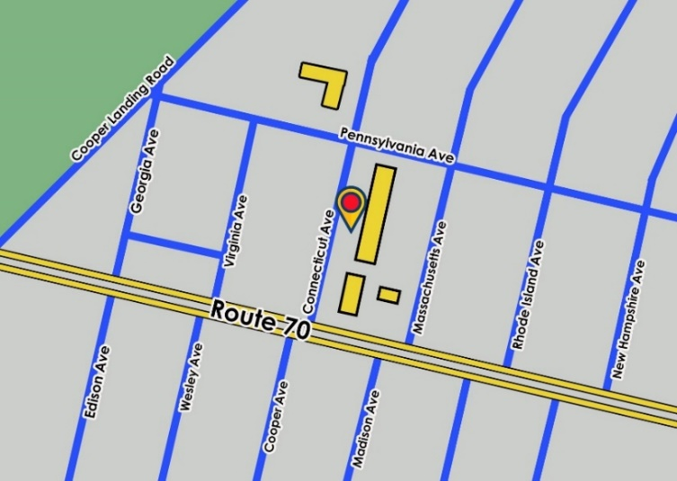
Two- and three-dimensional artwork can be dropped off at Y.A.L.E. School of NJ, Ellisburg Campus on the dates and times below OR by appointment by contacting Karen Donnelly (kdonnelly@yaleschoolnj.com). Artwork will be accepted at the door closest to the flagpole on the drop-off dates listed below. Entries can also be mailed to the address below with ‘Attn: Art Show’ on the envelope or package. All artwork must be received or dropped off by Thursday, April 20.
Please include a return shipping label with any mailed entries; please note that the USPS will honor shipment of packages past the denoted 3-day return shipment date. Return shipping labels can be purchased online at USPS.com for a flat rate.

Y.A.L.E. School of NJ, Ellisburg Campus
11 Connecticut Ave
Cherry Hill, NJ 08002

Drop Off Dates & Times:
April 19 & April 20 from 3 p.m. - 5:30 p.m.

Community Drop-off Boxes
The following library partners have generously allowed us to place artwork drop-off boxes at their locations. Please attach your completed submission form and artwork labels with a paperclip to all entries prior to drop- off. Note that the locations are unable to accept three-dimensional artworks (ceramics, sculptures, etc.) or artwork exceeding 23” x 13” in size as that is the interior dimensions of the drop-off bin. The lid to drop-off bins must be closed.
The final day for drop-off boxes is April 20.
Eastwick Library  2851 Island Ave  Philadelphia, PA 19153  Library Hours:  Sunday: Closed  Monday: 12 p.m. - 8 p.m.  Tuesday: 10 a.m. - 6 p.m.  Wednesday: 12 p.m. - 8 p.m.  Thursday: 10 a.m. - 6 p.m.  Friday: 10 a.m. - 5 p.m.  Saturday: Closed  Parking is available on the street and in the adjoining parking lot.  The drop-off box is located in the Children’s Literature section of the library. | Moorestown Library  111 W 2nd St Moorestown, NJ 08057  Library Hours:  Sunday: Closed  Monday: 9:30 a.m. - 9 p.m.  Tuesday: 9:30 a.m. - 9 pm.  Wednesday: 9:30 a.m. - 9 p.m.  Thursday: 9:30 a.m. - 9 p.m.  Friday: 9:30 a.m. - 5 p.m.  Saturday: 9:30 a.m. - 5 p.m.  Parking is available in the adjoining parking lot.  The drop-off box is located in the main lobby of the library.

Section 3 – Types of Submissions and Criteria by Category

Three-Dimensional Media Artworks
Types Accepted: | Criteria:
- Ceramics  - Cardboard or Paper Sculptures  - Textile Artworks  - Mixed Media  - Wood Sculptures  - Metal/Wire Sculptures  - Mosaics | - Dimensions should not exceed 3’ x 4’ in square footage.  - Artworks should not have any sharp or unsafe components or textures that are visible.  - Artworks should not require any type of wall mounting.  Note: Three-dimensional artworks cannot be dropped off at library drop- off boxes due to space and artwork security.
Two-Dimensional Media Artworks
Types Accepted: | Criteria:
- Drawings  - Paintings  - Collages  - Digital Prints  - Photography  - Mixed Media  - Printmaking  - Textiles | - Dimensions should not exceed 18” x 24”.  - Artwork should not be framed unless a tripod stand is provided when the artwork is dropped off. Library drop-off boxes will not accept any props.  - Matted artworks will be accepted.

Digital Artworks
Types Accepted: | Criteria:
- Videos or Animations  - Photographs  - Graphic Designs | - File must be emailed to kdonnelly@yaleschoolnj.com.  - Video file formats must be submitted as .AVI, .MOV, .MP4, or .GIF  - Image file formats must be submitted as .PNG, .JPG, or .JPEG  - If the file is large, it is recommended that you upload the file on Google Drive or Dropbox and send the file link to the email address above.  Note: All digital entries will be displayed on trolly flat screen TVs that will run on a loop rotation. All submitted digital artworks must not be plagiarized from another source.
Collaborative Artworks
Types Accepted: | Criteria:
- All media listed above | - Dimensions should not exceed 5’ x 6’ in square footage.  - Artworks should not have any sharp or unsafe components or textures that are visible.  - Artworks should not require any type of wall mounting without first contacting Karen Donnelly (kdonnelly@yaleschoolnj.com) to make sure that the artwork can be accommodated.  Note: Three-dimensional artworks cannot be dropped off at library drop-off boxes.

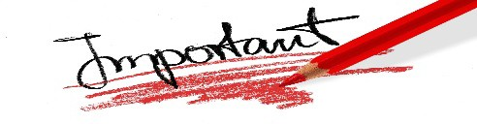
Section 4 – Display Recommendations

If the artwork requires a table display stand such as a plate display stand or tripod, it is recommended that you provide those items when you drop off the artwork. The prop can be attached to the artwork with string or tape, or packaged inside of a labeled box. Y.A.L.E. School of NJ will make every effort to provide display props, but these types of display props may be limited. Also, please note that props, displays, and three-dimensional artworks cannot be dropped off at library drop-off box locations.

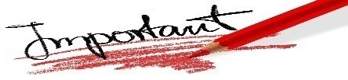
Section 5 – Juried Categories (OPTIONAL)
The Tri-State DisAbility Art Show offers juried categories for any student wishing to submit juried entries. Submitting juried entries is completely OPTIONAL. All artwork will be displayed, regardless of whether or not it is entered into a juried category.

All participants in juried categories will receive individual award recognition, an award certificate, and an award ribbon. No entry into a juried category will be excluded.

Note: If a student is submitting two art entries, only one of those artworks can be submitted to a juried category. Please indicate which of the two pieces of art is being submitted to the juried category by drawing or attaching a small star on the back of the artwork so that the correct artwork can be submitted to the juried category. (See categories below).

Juried Categories | Grades | Jurors
(Category 1) Penn Museum Awards – “Crossroads of Cultures” Inspired by the Penn Museum's newest gallery, the Eastern Mediterranean Gallery, create a piece of artwork that relates to or is inspired by the art or innovations of an ancient culture. | K-12 | Penn Museum - Education Program
(Category 2) Art Educators of New Jersey – Elementary School Juried Category  Entries in this category are from elementary students in New Jersey.  All media accepted. | NJ students in grades K-5 | Art Educators of New Jersey  Advisory Council  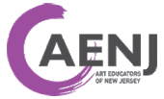
(Category 3) Art Educators of New Jersey – Middle School Juried Category  Entries in this category are from middle school students in New Jersey. All media accepted. | NJ students in grades 6-8
(Category 4) Art Educators of New Jersey – High School Juried Category  Entries from this category are from high school students in New Jersey. All media accepted. | NJ students in grades 9-12
(Category 5) Pennsylvania Art Education Association – Elementary School Juried Entries  Entries from this category are from elementary students in Pennsylvania. All media accepted. | PA students in grades K-5 | Pennsylvania Art Education Association - Board of Directors  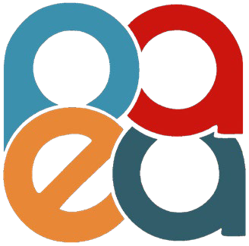
(Category 6) Pennsylvania Art Education Association – Middle School Juried Category  Entries in this category are from middle school students in Pennsylvania. All media accepted. | PA students in grades 6-8
(Category 7) Pennsylvania Art Education Association – High School Juried Category  Entries in this category are from high school students in Pennsylvania. All media accepted. | PA students in grades 9-12
(Category 8) “Art, Mind, Body” Award  Sponsored by Perkins Center for the Arts  Perkins Center for the Arts is proud to sponsor the “Art, Mind, Body” category. Self-Expression through artistic modalities supports the mental, social-emotional, and physical health of all community members. Perkins promotes artistic self-expression and encourages individuals to engage in the practice of art making as a means of fulfillment and joy that ultimately benefits their mental and physical wellbeing. Young artists are encouraged to submit artworks that embody self-expression and/or wellness, as interpreted by the young artist’s vision. All media accepted. | K-12 | Perkins Center for the Arts  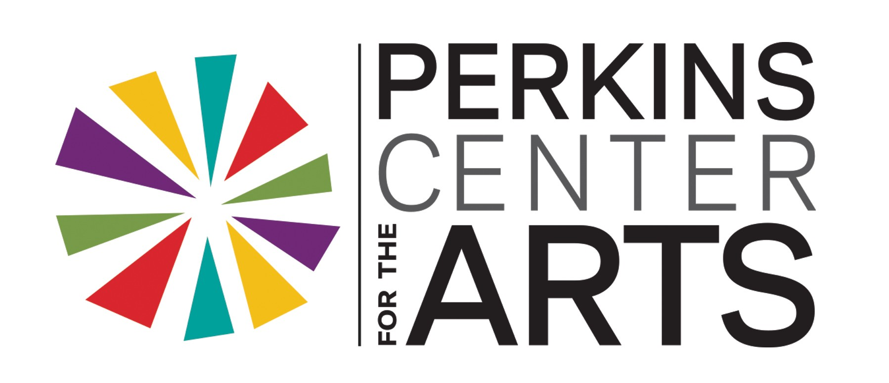
(Category 9) Say It With Clay – “Texturize It!” (Media specific)  Entries into this category are ceramic/polymer artworks that utilize texture as a form of creative investigation. Ceramics can either be hand-built or wheel-thrown. Media utilized may include ceramics, air dry clay, or oven-baked polymer clay. | K-12 | Say It With Clay  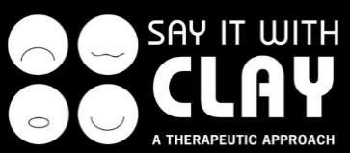

Section 6 – Artwork Pick-Up Information

Artwork must be picked up after the event at Y.A.L.E. School of NJ, Ellisburg Campus. Please see below for the pickup dates and times. Pick-up appointments may also be arranged by contacting Karen Donnelly (kdonnelly@yaleschoolnj.com). Artwork that is mailed to the school address with a return shipping label enclosed will be mailed back after the art show has ended.

Monday, May 1 – 3 p.m. - 5 p.m. | Friday, May 5 – 3 p.m. - 5 p.m.

About Y.A.L.E. School of New Jersey

Y.A.L.E. School of New Jersey is pleased to present the Tri-State DisAbility Art Show for its third year. Established in 1976, Y.A.L.E. School of NJ is a state-approved private school serving students in the tri-state area with campuses in New Jersey and Pennsylvania. Y.A.L.E. School of NJ provides a positive approach to students ages 3-21 with disabilities, who need a specialized setting in order to benefit from education. Y.A.L.E. School of NJ specializes in supporting students with social, emotional, learning, and behavioral disabilities. Programs are fully approved and monitored by the New Jersey Department of Education and comply with state and federal rules and regulations. Most students at Y.A.L.E. Schools of NJ are referred by their local school district; they attend at no cost to parents.

Learn more online:

www.yaleschoolnj.com

www.yaleschoolpa.com

facebook.com/yaleschoolnj
facebook.com/yaleschoolpa

@yaleschoolnj

@yaleschoolnj

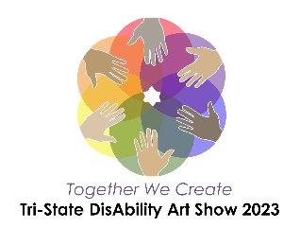
SUBMISSION FORM

Tri-State DisAbility Art Show April 28 - 29
Y.A.L.E. School, Ellisburg Campus 11 Connecticut Ave Cherry Hill, NJ 08002
The Tri-State DisAbility Art Show is an inclusive event celebrating the talents and experiences of young artists in K-12 who are from New Jersey, Pennsylvania, or Delaware and who have either an IEP or 504 plan. Participation is entirely free and open to students in public and private schools in the tri-state area.
Opening Reception: Friday, April 28 from 6 p.m. to 9 p.m. – Tour the gallery and attend a short awards presentation; children of all ages will also enjoy craft table activities.
Art Show Gallery Hours: Saturday, April 29 from 10 a.m. to 3 p.m. – Enjoy the gallery displays and craft table activities for kids.

All Artwork must be received by April 20 to be included in the art show. Please use the Artwork Labels enclosed in the packet to identify each entry by attaching the label to the bottom right corner of the artwork when submitting.
A Teacher or Guardian must also complete the Artwork Submission Form Below. Only one submission form is required per guardian/teacher.
Limit of 2 entries per young artist. All entries are guaranteed to be displayed regardless of whether or not the artwork is submitted to a juried category. Please see the Artwork Submission Guidelines for all relevant information regarding submissions.
Note: If a student is submitting 2 works of art, only 1 of those artworks may be submitted to a juried category. Please indicate which of the 2 pieces is being submitted to the juried category by drawing or attaching a small star on the back of the artwork. Every student submitting to a juried category will receive an award.

Artwork Submission Form

Full Name of Teacher or Guardian:
Teacher/Guardian Email Address:
Teacher/Guardian Phone Number:
Relationship to the Child/ren:
- Teacher
- Parent/Guardian
- Other:

School Name: | School Address:

I, , the guardian/teacher of all participating children listed below grant permission for the Y.A.L.E. School of New Jersey and Y.A.L.E. School of Pennsylvania Inc. to display submitted artworks for the Tri-State DisAbility Art Show 2023. I also grant permission for artworks with students’ full name and school to be used or displayed on social media, news stations and/or newspapers, or on promotional material for following art shows. I am at least 18 years of age or older.
Signature of Guardian or Teacher: Date:

List of Participating Students (first & last names, grade level, juried category)
Student First Name: | Student Last Name: | Grade (K-12): | Juried Artwork Category # (OPTIONAL)

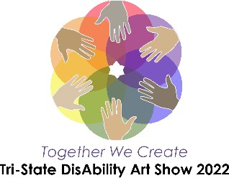
Artwork Labels
These artwork display labels are included for your convenience. If you choose to make your own artwork labels, please use the same format that is listed below. Adding an artwork title is optional.

Name: Grade:
School:
Name:
Grade: School:
Name: Grade:
School:
Name: Grade:
School:
Name: Grade:
School:
Name: Grade:
School:
Name: Grade:
School:
Name: Grade:
School:
Name:
Grade: School:
Name: Grade:
School:
Name: Grade:
School:
Name: Grade:
School:

